932533478

Agreement url:   
  
  
  
https://journal.nephrolog.ru/jour/issue/archive

English Version

Current Issue

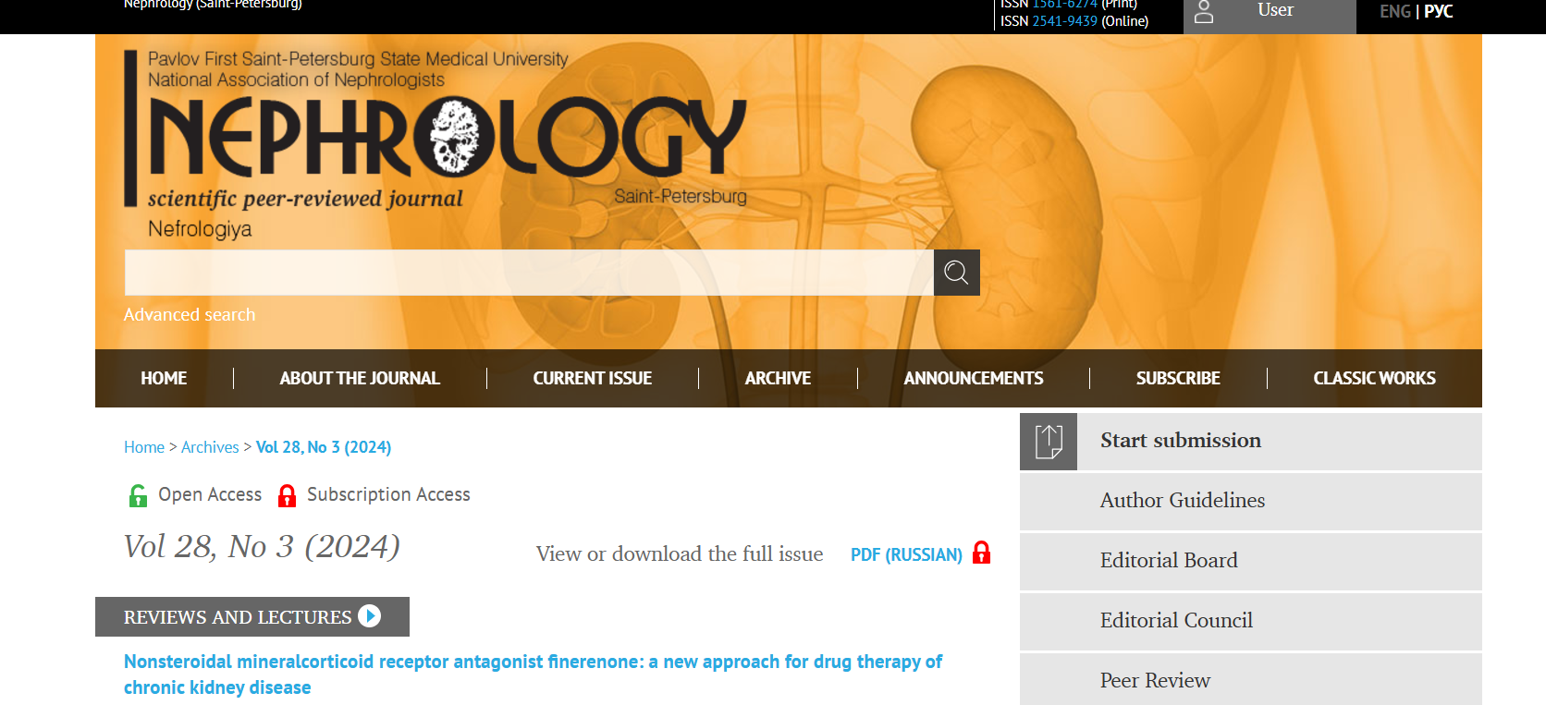

Page Range

English Title

Publication year, volume, issue

DOI

Download PDF

* **In here both English and Russian toc needs to be captured so choose language option from website language conversion . then go to the Table of content page right click and save as pdf and merge in to one.**